THEME: Partnership, collaboration across professions
The Botswana Presidential Collection @BIUST: The concept and preparatory processes

Ms Amogelang Kerebotswe
Library Assistant
Directorate of Library Services
Botswana International University of Science and Technology
Palapye, Botswana
kerebotswea@biust.ac.bw

Ms Olga Tladi
Library Officer
Directorate of Library Services
Botswana International University of Science and Technology
Palapye,Botswana
tladio@biust.ac.bw

Dr Ayanda Lebele
Library Director
Directorate of Library Services
Botswana International University of Science and Technology
Palapye,Botswana
lebelea@biust.ac.bw

Abstract
On 10th February 2018, The Botswana International University of Science and Technology (BIUST) officially launched a collection that serves as incubation of the Botswana Presidential library. The collection is a foundation of a primer repository of textual materials; drawings; paintings, photographs, artefacts and many other visual materials that illuminate the legacy and era of all the Botswana presidents.
BIUST library intends to develop this as Special Holdings or Rare Collections that will uniquely augment the already existing legal repositories of BNARS, UB and BNLS whose focus is presently very broad or on generalities of Botswana Literary works. The Presidential library @ BIUST instead adopts a thematic scope; and also uniquely triangulates elements of libraries; archives and museums in the collection, preservation and dissemination of such information ( 3 in 1)
This paper therefore is a narrative that shares experiences on the concept of the presidential collection @BIUST since it is new concept in the country with view of fostering collaborations in the form of ideas, helping others with interest in the same project or undertaking, share challenges, lessons learnt and possible recommendations.
The paper also demonstrates strategies in the development of operational policies, strategies and guidelines on the growth of both the space and the collection. It importantly highlights collaboration and cooperation of resources and expertise with already designated national and international special collections.

Keywords: Special collection, presidential library, collaborations, primer repository, incubation, thematic, stakeholders.

Introduction
For centuries, special collections have served as historical materials that provide essential clues to the past. These collections, both print and electronic have been useful to researchers in the history of particular individuals; entities; organizations; specific events or broader societal trends. The collections may include Letters, emails, diaries, books, photos that are accumulated over the years so as to give vital and unique information regarding life or the history of an individual or place (Society of American Archivists, 2013).RUSA (2012: 59) points out that the literature on special collections mainly focuses on the use and maintenance of various media. This paper instead looks at strategies in the development and operationalization of the collections.
In February 2018, BIUST officially launched an incubation of a collection dubbed the Presidential collection @BIUST, as a foundation of a primer repository of textual and visual materials that illuminate the legacy and era of all the Botswana presidents. The initiative is informed by the concept of a presidential library which formally began in 1939when President Franklin Roosevelt of USA donated his personal and presidential papers to the federal government.
In Botswana substantial collections on Botswana presidents may be found scattered all over in multiple private and public collections. This may be blamed on the 1967 National Library Service Act’s silence on the concept of National Presidential Libraries. Neither the Botswana National Archives Act of 1978, amended in 2007, nor the National Museum and Art Gallery Act of September 1967 is clear on the provisions of such an establishment.
In this specific initiative, BIUST library endeavours to develop a special holdings or rare collections in a way that triangulates elements of libraries; archives and museums in the collection, preservation and dissemination of such information ( 3 in 1). The intent is to uniquely augment the already existing legal repositories of Botswana National Archives and Records Services (BNARS), the University of Botswana (UB) and Botswana National Library Services (BNLS), Operational policies, strategies, and guidelines on the growth of both the space and the collection are as such done in cooperation and collaboration with these stake holders. It is a new concept in Botswana therefore ideal to share the experience.
BIUST background
The Botswana International University of Science and Technology is a Government of Botswana supported institution established through the BIUST Act (CAP 57:05) as a research intensive University that specialises in Engineering, Science and Technology .The University is a national strategic initiative that is intended to serve as one of the key platforms for transforming Botswana’s economy from being resource based to knowledge based through skills capacity building in Engineering, Science and Technology. It is located in Palapye. Its vision is to be a premier research-based university of science, engineering & technology internationally recognised for the quality and excellence of its teaching and learning; research and innovation and Engagement. BIUST University has three faculties being; Faculty of Engineering &Technology, Faculty of Sciences and lastly the Centre for management, entrepreneurship and general education.
Directorate of library services
The mission of the library is to provide resources and services that are responsive and aligned to the educational, research and outreach activities of staff and students. The library services that are provided to library patrons include loaning of materials, access to BIUST online catalogue, special collections in the form of Institutional repository, presidential collection, reading spaces both in library & remote and internet services.
Special collections
Defined
Arizona state library archives and public records (2018) highlight that a special collection is one that is defined by virtue of the unifying factor of a single topic or subject. Such collections are usually the purview of national libraries, state libraries, historical societies, and research institutions. It can therefore be concluded that Special collections are unusually rare, stored separately from the regular library collections, topical, can centre on a person / persons. They can also be a repository in a limited subject area to distinguish the institution or serve as flag ship. It is a value adding service to the library and can contain artefacts like campaign buttons or even letters. Special collections libraries carefully preserve collections of written, visual, audible, and electronic material created by private citizens both past and present. Such repositories ensure that these personal and family records will be available for research by generations to come.
Types
There are different types of special collections depending on the purpose and scope. As Herroda (2000) indicates “each collection large or small has its own story, just like each item in an antique shop” pg. 163.Examples of such collection can be institutional repositories, rare collections and thematic collections.
The University of Manchester Library (2018) outlines the benefit of such collections constituting primary (first-hand) evidence unlike secondary sources in historical and administrative research and are often part of the larger cultural record, often of a local or regional community .
Literature review
Presidential library
Infoplease organization (2018) describe that “these are not traditional libraries, but rather repositories for preserving and making available the papers, records, and other historical materials of the presidents”.

History of presidential libraries
According to The U.S. National Archives and Records Administration (2016), The Presidential Library system formally began in 1939, in the U.S.A. when President Franklin Roosevelt donated his personal and Presidential papers to the Federal Government. This existed as his private collection. Roosevelt's decision stemmed from his belief that Presidential papers were an important part of the national heritage and should be accessible to the public. He asked the National Archives to take custody of his papers and other historical materials and to administer his library. In 1955, the Congress passed the Presidential Libraries Act of 1955, establishing a system of privately erected and federally maintained libraries. The Act encouraged other Presidents to donate their historical materials to the government and ensured the preservation of Presidential papers and their availability to the American people. Under this and subsequent acts, nine more libraries have been established. To date we have presidential libraries wide spread across the globe. George H. W. Bush Library can be cited in America, Thabo Mbeki presidential library in South Africa and the Obasanjo in Nigeria in African context.
Presidential collection @ BIUST as a special collection
As already highlighted, the collection illuminates the legacy and era of all the Botswana presidents, is thematic in scope and also uniquely triangulates elements of libraries; archives and museums in the collection, preservation and dissemination of such information (3- in- 1).

PRESIDENTIAL COLLECTION @BIUST

Figure 2: Triangulation of the elements of libraries, museum, and archives.

Rationale for collection

Radijeng (2013) highlights that libraries are a key place for dispensing government information, people already come to the library for information and other activities, therefore they become perfect locations for distributing government information. As Herroda (2000) has indicated in his study on collecting for special collections library,”…therein lies the wealth of a special collections library; not just the collections themselves, but the stories behind them, the stories that impassion the hearts of curators”. pg 163. Scholarly research depends ultimately on the availability of primary sources and research Libraries preserve and provide such primary resources as part of their fundamental mission. Having special collections in the form of presidential collection @ BIUST is to bring together information on former and sitting presidents of the Republic of Botswana and the roadmaps of their respective governments so as to create accessibility to such information, whether it is within the BIUST collection or elsewhere whilst ensuring their longevity. As a value adding service this is in line with strategic initiative of the University of research and innovation excellence.

Currently in the absence of the Presidential libraries act, substantial collections on Botswana presidents may be found in multiple private and public collections
.
Collaboration and cooperation with stakeholders
At the moment BIUST Library is developing and refining the operational policies, strategies, and guidelines on the growth of both the space and the collection. This is done through collaborative efforts with relevant national and international stakeholders. Recently the Library held a stakeholders consultative meeting with Directors from the National museum, National Archives, National Library and University of Botswana Library, to solicit their views on how best we could develop this concept further.
The shared Vision
The mandate of BNARS involves managing all public records throughout their life cycle from creation to disposition. This is achieved through Records Management and Archives Administration functions.
The National library’s mandate may be broadly summed as to preserve the national literary heritage and provision of information and educational services.
The Botswana national museum exist to protect, preserve and promote Botswana 's cultural and natural heritage for sustainable utilization thereof by collecting, researching, conserving and exhibiting for public education and appreciation
The identified Library, Archives, Museum institutions have a national administrative mandate to work together towards universal information access. Although these entities have traditionally held distinct roles in shaping interpretations of knowledge, their stated organizational missions transcend beyond just harvesting and hosting information sources. There is a connecting thread of managing information and knowledge for both research and people’s development. The mandates and missions also denote partnership in research and knowledge creation, conservation and dissemination to the nation. The noted legal repositories will be very instrumental in continued refining of the scope and utility parameters of the collection It is envisaged that these stakeholders’ activities would eventually benefit and integrate with those of the Presidential collection at BIUST. This collaboration will enable sharing of national resources; enhance access in areas of scholarly interest and expertise towards realization of the vision 2036 national vision pillar of a knowledge based economy. A concept paper for this collaboration is being developed.

The presidential collection at BIUST is also collaborating with professional library organizations like Botswana Library Association and Palapye Librarians forum. International special collections include University of Cape Peninsula, Stellenbosch and Thabo Mbeki Presidential Library.
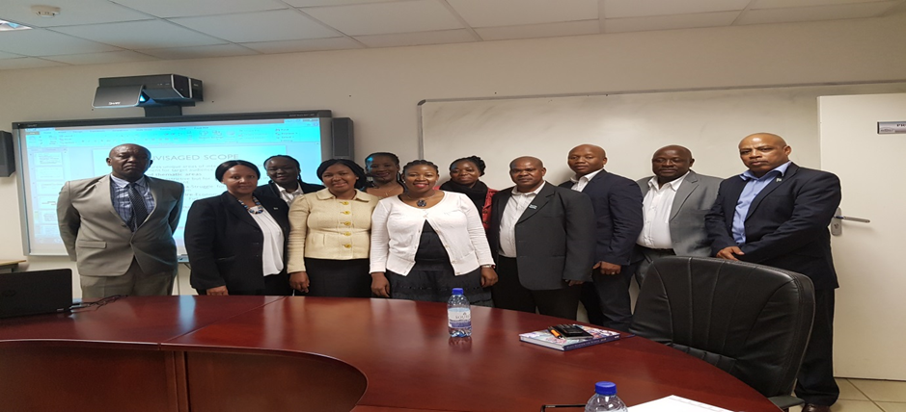
Figure 1: Stakeholder engagement meeting for collaborative purposes. With Directors of UB, BNARS, Museum, and BNLS.
Proposed services will include, research common which will act as a place for generation and exchange of research through scholarly activities like debates seminars and public lectures. The collection will contribute to bibliographic description to the global catalogues and information sharing platforms like OCLC and Sabinet. The libraries of the world will know about the collections through such platforms. The collection will also have a secure reading space that is cognisant of the collection level of sensitivity with users having access to a broad range of other BIUST library services and resources.
Proposed collaborative activities in pipeline include;
• Lecture/ seminar in collaboration with Sir Ketumile foundation ( 93rd Birthday commemoration)
• Expanded Barclays Mogae Scholarship
• First lady talk on Internationalization of Setswana Values
• Celebration of Botswana Week

Experiences in building the collection
Collection development
Currently there is no act governing the establishment of the presidential library.There are no written guidelines or policy in relation to the collection, at the moment and this are still being defined.
Collection coverage
The collection at the moment captures the focus of their administration rather than being broad in. This allows a defined, thematic collection. The identified areas are;
- Sir Seretse Khama-Struggle for democracy and liberation from racism
- Sir Ketumile Masire-Economic Transformation
- Sir Festus Mogae- Activism on HIV/AIDS
- Sir Seretse Khama Ian Khama-Poverty eradication and service delivery, wildlife conservation, national security.

The intention is to cover these areas in depth and go on to grow other
thematic areas with time as the collection grows. Example foreign relations, political influence. The services and the collection are currently provided onsite, however it is envisaged that they will be remotely provided or accessible.

FORMAT | NO OF HOLDINGS
Books | 14
Pamphlets | 33
Newspaper articles | 1
Journal articles | 6
Photos | 31
Total | 90 items
Table 1: Statistics of the collection and its constituents (as at May 2018)
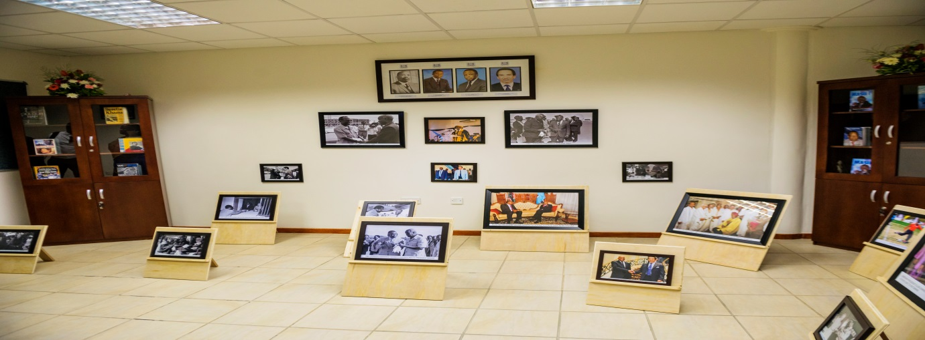
Figure 2: The display room with the presidents’ photos and books to kick start the incubation of the presidential collection.
ITEM (FORMAT) | TITLE | PICTURE
BOOK | Khama;real leadership for real delivery(2008-2013) edited by Lawrence Ookeditse | 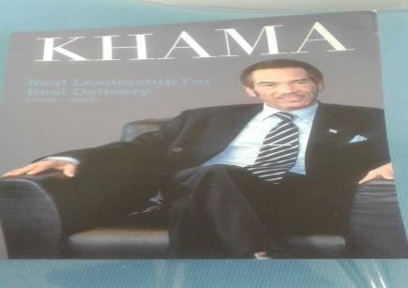
poster | Members of the first parliament , 1965-1969. | 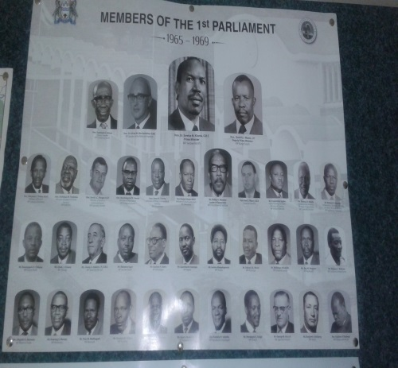
Journal article | The Lusaka Agreement:Prospects for peace in the Democratic Republic of Congo | 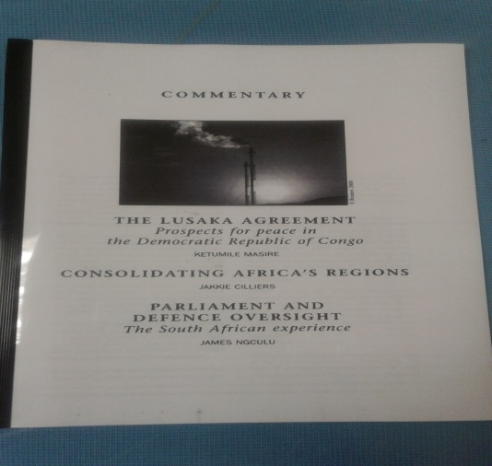
Book | Colour bar: the triumph of Seretse khama and his nation. | 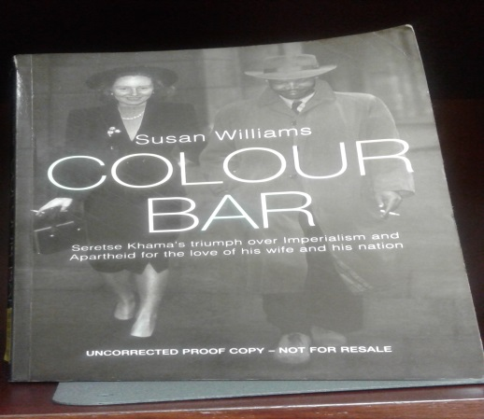

Table 2: Sample of some of the items currently in the collection
Collecting strategies
In collecting materials, the following are strategies that we currently use:
• Harvesting from internet sources
• Donations.
• Marketing drives –reaching out to people
- Stakeholders –in form of External collaborations e.g. Parliament, BIDPA, Masire foundation
• Purchase of books from vendors and photos from Department of information services
Preservation and conservation plans

Our library currently does not have in place a purpose built room that takes cognisance the environmental considerations for special collections. Factors such as the temperature and humidity of the air and the presence of pests, such as insects cause damage and deterioration to the collection. However we do try to maintain cold temperature at 16 °C. At times we do fumigate the collection to reduce pests.
Launch
This was in parallel with the 2ndgraduation of the university and was launched by Former president, His Excellency Lieutenant General Dr. Seretse Khama Ian Khama .This was captured on the news. Television and Daily news.

Staffing
There are currently two personnel, Library officer and Library assistant in the presidential collection both trained in librarianship only.

Marketing
The audience is diverse for special collections. The primary audience for the special collection at BIUST library is the staff and students .The secondary audience are other universities who are in collaboration with the library through research and cooperation, visitors and the general public.
The special collection team utilize different platforms to promote the collection. These are social media in the form of Facebook, the university intranet (Bitranet), memos circulated in notice boards, faculty invitations and group presentations.

Valuable lessons learnt
Staffing
The staffing and skills set required for special collections are not the same as the different components of the collection demands unique treatment. The marriage of the different aspects of the collection e.g. archives, library has got demands in staffing. But the similarity lies in the issue of organizing information for easy access to clients. The management of heritage collections, archival collection, the materiality of books and other collection artefacts requires a unique mix of knowledge and skills. Archaeologists, conservator, researcher, curators are ideal in museum artefacts. For archival collections skills in archives is ideal .For library collection a librarian will be best suited for that. Other skills that are vital include supervisory skills and customer service.
Metadata/classification
Processing of materials in special collections is different. The different aspects of the collection have their own standards. RDA is ideal as it caters for different formats. This is a relatively new phenomenon which is under exploited.
Fiscal considerations
There needs to be a budget provision for the collection from the main library budget. It is important to note that rare and fragile materials are expensive to acquire, maintain, reproduce, and digitize.
Lindsey J. Smith.(2015) points that,
“Special collections and their staff do not operate in a vacuum, but rather in a world of competitive funding opportunities within the university and a continued needto showcase the importance of their collections in order to maintain and provide access to
these materials in the future.”pg 4.
Collecting strategies
This is undefined and non-traditional in that there are no prescribed suppliers and not much is available in open shelf for purchase. A lot of literature is missing on the presidents with most literary items out of print. A lot of grey literature from government offices is what is mostly available. For donations there needs to be formal agreements and conditions.
Outreach
Marketing the presidential collection outside the walls of the library is a challenge as materials need to be secured and protected from external factors like theft, damage as they are irreplaceable and rare to find. There is need for dummies of the collection.
Copyright issues
Copyright implications affect access in that some materials like photos, videos need to have copyrights cleared before they can be put up for public access.
Environmental considerations
Special collections require a secure environment that is conducive for the preservation of the materials with proper provisions even for monitoring materials. It is therefore for this reason that the library does not accept artefacts and other non-paper formats that needs additional care.
Operational rules
The special collection is a restricted area and operates with a different set of rules from the main library. The operating times, loan period, loan quantity, and conditions are different. This is in line with the mandate to prolong their lifespan.

Conclusion & recommendations.
As stated in the sustainable Development goals (SDG) a well-informed society contributes significantly to the development of the nation as the availability of information resources would promote peaceful and inclusive societies for sustainable development, providing access to justice for all and build effective, accountable and inclusive institutions at all levels,(John,2016).One of Botswana national vision 2036 pillars is to transform Botswana into knowledge based economy. The role of libraries in this regard is to acquire, organise, and disseminate information and provide a platform for community engagement .Special collections contain a vast array of items, and many of those are relevant to personal projects and other forms of research that may not directly be related to scholarly work. The special collection in the form of presidential collection at BIUST is a noble initiative to preserve presidential legacy. It is also a key place for dispensing government information and part of a larger historical record. Other countries are ahead in this area in that they are governed by the presidential act hence have got presidential libraries whereas here in Botswana we do not have any guiding act yet. The presidential collection at BIUST has got so much potential to grow with the success of collaborative efforts of the different stakeholders involved. Collecting for presidential collection is not easy, non-traditional and expensive. It also requires unique environments and skills capacity to manage. As the collection grows there is a need to establish and maintain an ongoing dialog with stakeholders and make collaborative agreements to enhance access. With the growth of the collection at BIUST and hopefully other institutions, it is envisaged that the formulation of the Presidential act will eventually be realized by government hence trigger the existence of such libraries across the country whether privately or by government.
REFERENCES
American Library Association, (2012)RUSA Guidelines for Establishing Local History Collections. Reference & User Services Quarterly, [S.l.], v. 52, n. 1, p. 59-60, September 2012. ISSN 1094-9054. Retrieved on 28 June 2018 fromhttps://journals.ala.org/index.php/rusq/article/view/3810/4176
Herrada,J. (2000) Continuing a legacy: collecting for a special collections library, Collection Building, Vol. 19 Issue: 4, pp.163-165, Retrieved on 11 May 2018 from https://doi.org/10.1108/01604950010354840
Infoplease organization (2018) Presidential libraries. Sandbox Networks, Inc., publishing as InfopleaseRetrieved on 18 June 2018 fromhttps://www.infoplease.com/presidential-libraries
John, D.K.(2016)The Role of the Library in Achieving Vision 2030 Goals, Bartos Institute for constructive engagement of conflict, CEC journal,issue 2, October 10, 2016. Retrieved on 18 May 2018 fromhttp://scalar.usc.edu/works/cec-journal-issue-2/the-role-of-the-library-in-achieving-vision-2030-goals
Purdue University (2018)Primary Sources in Archives & Special Collections: What is a Special Collection? Retrieved on 11 June 2018 from http://guides.lib.purdue.edu/c.php?g=352889&p=2378065
Radijeng, K. (2013) The Role of Libraries in the Attainment of Botswana Vision 2016. Botswana National productivity Centre, Gaborone. Retrieved on 14 may 2018 from: http://library.ifla.org/258/1/201-radijeng-en.pdf [October 2016]
Smith,L.(2015)Users and Special Collections: Access and Outreach Awareness at the University of North Carolina’s Wilson Library. A Master’s Paper for the M.S. in L.S degree. April, 2015. 53 pages.Retrieved on 19 May 2018 from https://cdr.lib.unc.edu/indexablecontent/uuid:fc265f94-a03f-4973-8192-3879ed5f579e
Society of American Archivists (2013)Donating Your Personal or Family Records to a Repository. Retrieved on 12 May 2018 from https://www2.archivists.org/publications/brochures/donating-familyrecs.Accessed
The University of Manchester Library (2018) How can Special Collections assist me with my learning or research.Retrieved on 12 June 2018 fromhttp://www.library.manchester.ac.uk/special-collections/find-out-more-about-special-collections/assist-with-learning-or-research/.
U.S. National Archives and Records Administration (2016),Presidential libraries.Retrieved on 28 June 2018 from https://www.archives.gov/
Vision 2036 presidential task group (2016) Achieving prosperity for all.Vision 2036 booklet.Lentswe la Lesedi Publishers, Gaborone Botswana.
Arizona state library archives and public records () Selection: Defining & Managing Special Collections. Retrieved on 15 June 2018 from https://azlibrary.gov/libdev/continuing-education/cdt/selection-special-collections

Bibliographic note
Olga Tladi is the library officer at BIUST library working in the presidential collection@BIUST.
Amogelang Kerebotswe is the library assistant working in the presidential collection @BIUST.

